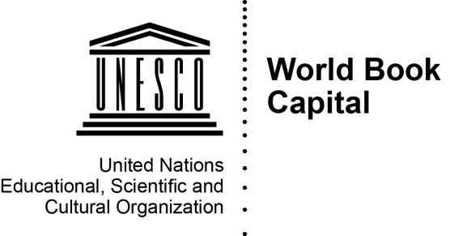
APPLICATION FORM

Call for applications 2018

This application form, duly completed, must be sent as an attachment by email to wbcc@unesco.org, with the “subject”: Application [name of the candidate-city].
The following documents must be also attached (in one of UNESCO Secretariat working languages – English or French):
(i) A support letter from the Mayor of the candidate-city;
(ii) A formal letter of endorsement of the candidature from the National Commission for UNESCO of the country in which the city is located;
(iii) Two formal letters of support from active national professional association(s);
(iv) Three photos of your city related to books (JPEG, max. 3MB);
(v) The “Cession of rights and register of photos” form dully filled.
Application forms, accompanied by the documents described above, must be submitted by email to the UNESCO Secretariat no later than 31 May at midnight (Central European Time) using the following address: wbcc@unesco.org. Applications that are not received in the required format, as well as those that are incomplete and/or received after the above-mentioned deadline will not be considered.

- NAME OF CITY

- COUNTRY

- CONTACTS

3.1 Mayor of the City

Title (Mr/Ms/Mrs)
Surname
First name
Address
Tel:
Email:

3.2 Main contact

The main contact will be the focal point and correspondent for all communications concerning the UNESCO World Book Capital. He or she should belong to the unit or structure executing and managing the designation.

Title (Mr/Ms/Mrs)
Surname
First name
Institution/function
Status/Type of institution
Address
Tel:
Email:

Alternative contact:
Other important information:

- PRESENTATION OF THE CITY

Presentation of the main geographical, demographic, cultural and economic characteristics of the city; mode of governance, principal cultural facilities and infrastructures, international connections, etc. (1700 characters maximum).

- MAIN OBJECTIVES AND EXPECTED IMPACT

Presentation of the main motives behind the decision to submit an application to the UNESCO World Book Capital and the expected long-term impact of the designation for the sustainable development of the city (1200 characters maximum).

- PREPARATION PROCESS FOR THE APPLICATION

Presentation of the preparation process underlying the application and the members of the management team involved. The design and preparation of the application submitted by the city must involve various stakeholders, drawn from the private and public sectors as well as academia and civil society (1000 characters maximum).

- PRESENTATION OF THE ACTIVITY PROGRAMME

In this section the candidate city is invited to present an appropriate action plan describing the main initiatives that the city commits to undertake, within the framework of its designation.
The proposed initiatives must be specifically conceived for the World Book Capital and implemented during the city's term as Capital with long-term benefits for partners and society at large.
The action plan and proposed initiatives should be realistic, coherent and feasible. It is recommended to describe the main planned initiatives rather than multiple theoretical lists of actions.
The presentation of the action plan should notably include:
- A minimum of 5 programmes or projects to be implemented
- The objectives, the stakeholders involved in their implementation, the beneficiaries and the expected results
- Main facilities and infrastructures available and events such as fairs, conferences, and conventions organized by the city with the aim of promoting books
- International cooperation and partnerships to be developed
- A general outline of expenses foreseen and fund-raising strategies;
- A plan for communication and awareness

Date

For example, a letter of endorsement from the national writers’ association

