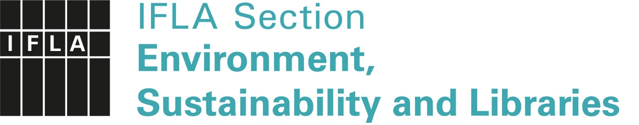

ENSULIB Annual Report 2019–2020 / Abstract
ENSULIB’s 2019–2020 Action Plan was based on the general aim that ENSULIB increases its ability to promote environmental awareness: the work we have done should become more effective with visibility increased worldwide. Moreover, the aim was that the discussion of Green and Sustainable Libraries gains momentum and receives much more attention. During 2019–2020, the number of involved corresponding members has been growing steadily and now there are 61 institutions plus 4 personal affiliates which have agreed to support ENSULIB when we become a section (September 2020). The plan is that, by 2021, the Special Interest Group (SIG) will have grown up to a Section, which will amplify the group’s engagement within IFLA.
Other objectives for ENSULIB 2019–2020 were the following:
1. Increase the ability to promote environmental awareness: the working of the unit becomes more effective with visibility increased worldwide. This progress helps us contribute IFLA Key Initiatives in the future and promote the United Nations 2030 Agenda for Sustainable Development.
2. The discussion of Green and Sustainable Libraries is gaining momentum and receives more attention. ENSULIB is increasingly promoting libraries' commitment to the implementation of the goals of the United Nations 2030 Agenda and SDGs. Environmental sustainability is also included in the IFLA Global Vision. These two main objectives were planned to be attained by the following actions:
- ENSULIB’s Open Session in IFLA WLIC 2020, Dublin
- ENSULIB’s Satellite meeting before IFLA WLIC 2020 in CORK
Unfortunately, due to the Covid-19 epidemic IFLA WLIC 2020 was cancelled and the satellite or open session could not be arranged.
- IFLA Green Library Award 2020
The aim was that the IFLA Green Library Award has established its status and become known to broader audiences. The Call for Submissions was circulated for the fifth year in a row and to our great delight more than 50 submissions were received from all around the world. More 30 LIS professionals stepped up to help with the reviewing process. They were a blend of LIS students, library professionals (from public and academic libraries) and architects as well. After much deliberation, the winner was selected: Thailand, Rangsit University Library: “Rangsit University Library and Sustainable Environment Management Report” Rangsit University Library is a private institution, yet it is accessible to locals, and reaches out to local schools and a prison as well as teachers and students. In terms of educating the community, this library holds activities to enhance a leadership role for environmental sustainable management. They have committed themselves to sustainability goals as a managerial framework, and this shows in their professional, systematic and well-documented approach. Sustainability permeates nearly all of their infrastructure, operations and educational goals in an exceptional way. The library monitors its energy, paper and water usage as well as other activities, thus making it possible to evaluate how well the goals are being met. Unfortunately, the winner could not be presented at that IFLA WLIC 2020 since the conference was canceled.
The five runners up for the award came from China, Croatia, Hungary, Senegal, and Sri Lanka. The wide variety of submissions created a rich experience as well as a mighty challenge for the reviewers. For instance, cool weather countries grapple with warming buildings, while those in hot climates aim to cool them. Submissions addressed different populations, scales of projects and institutional best practices. Through multiple conversations reviewers worked together, pooled their responses and were able to make decisions that celebrates such diversity.
- The Runner-ups (in alphabetic order):
  - China, Hangzhou Public Library: “Our Green Mission Defend the City
  - Croatia, Public Library “Juraj Šižgorić”, Sibenik: “Project Green Library”
  - Hungary, Ezüsthegy Library, Budapest: “Library in the Garden, Garden in the Library –Green Complexity in the Life of a Public Library”
  - Senegal, Lambaye Learning Center: “An Ecological Learning Center”
  - Sri Lanka, Battaramulla, National Environmental Information Centre: “Protect Environment Through the Information”
More: https://www.ifla.org/node/92963?og=479

- ENSULIB’s book project: Going Green: Implementing Sustainable Strategies in Libraries Around the World: Buildings, Management, Programmes, and Services. Edited by Petra Hauke, Harri Sahavirta, and Madeleine Charney. Berlin/Boston: De Gruyter Saur, 2018. (IFLA Publications, 177), online availability is provided.

- Contribution to the IFLA Strategic Plan/Key Initiatives: IFLA's strategic directions for 2016–2021 are: 1. Libraries in Society, 2. Information and Knowledge, 3. Cultural Heritage, 4. Capacity Building. ENSULIB has been targeting all these demands:
- Fostering green libraries that play an important role in raising awareness in terms of the UN Agenda 2030 Sustainable Development Goals
- Disseminating information and creating knowledge on environmental sustainability as one of the major challenges of our time
- Disseminating information and knowledge about the effect of climate change to cultural heritage objectives
- Encouraging libraries to play a role as examples through sustainable buildings and practices, as educators and enablers in promoting sustainability research (https://www.ifla.org/publications/node/81763).

